Lock Object name must begin with ‘E’ ie EZ or EY.

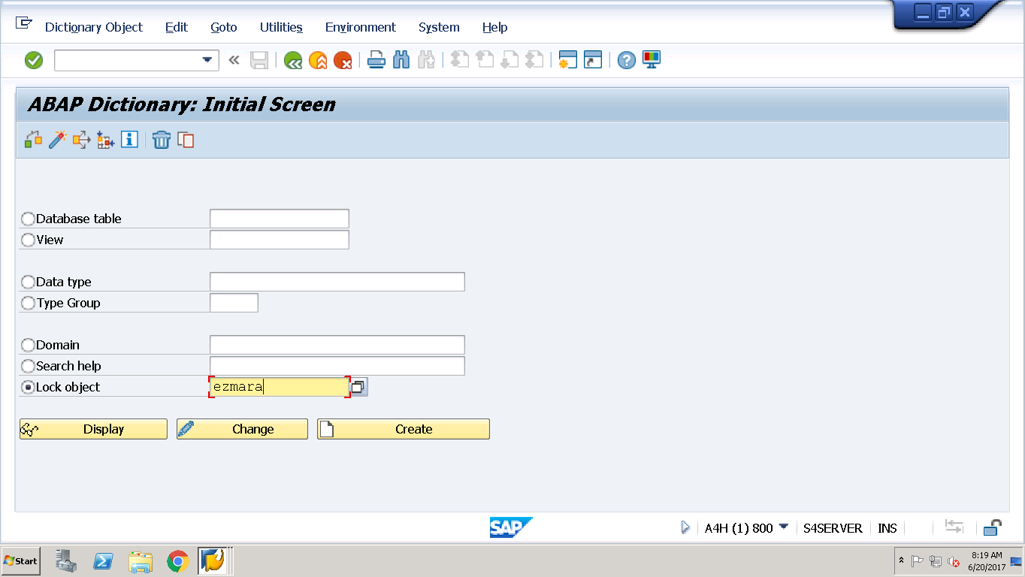

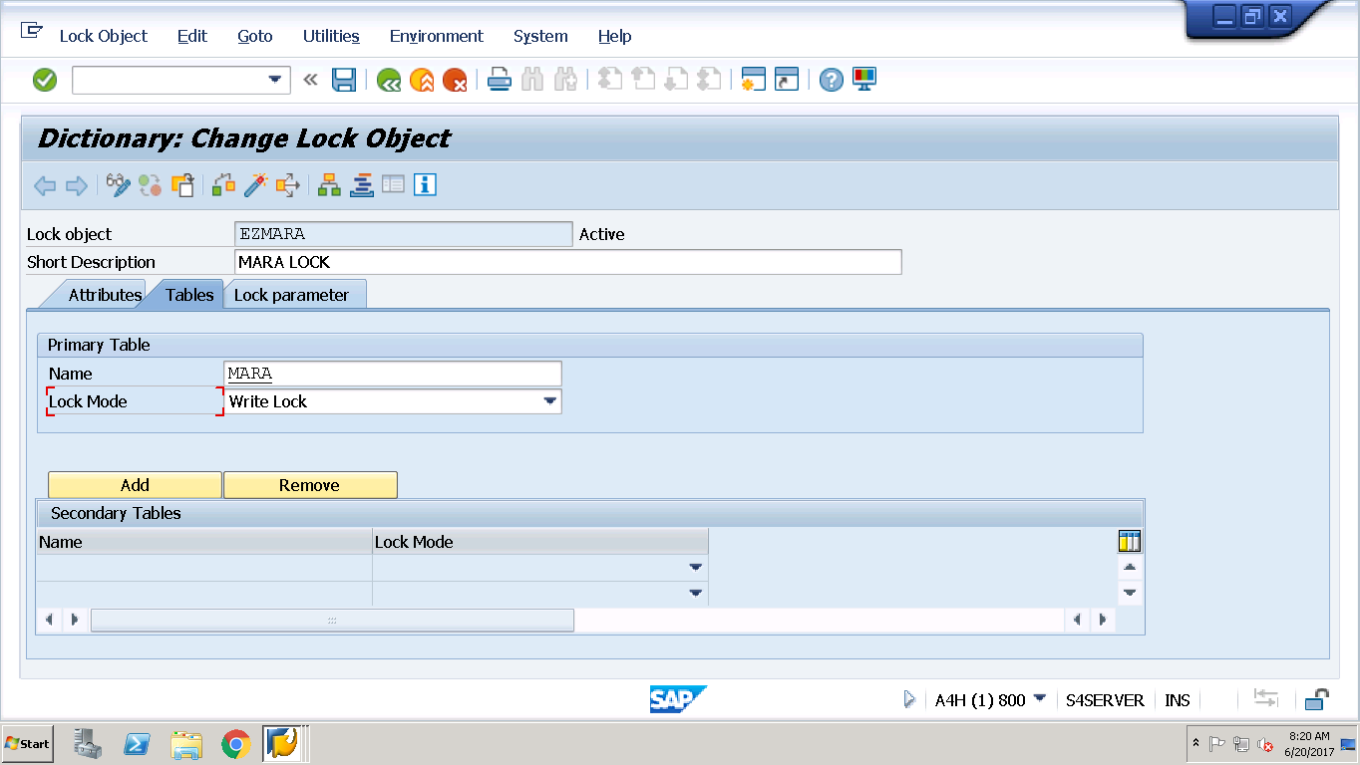

In General , Write Lock Make sense.

Lock Parameters are always on primary Key of the Table and can be verified . i.e

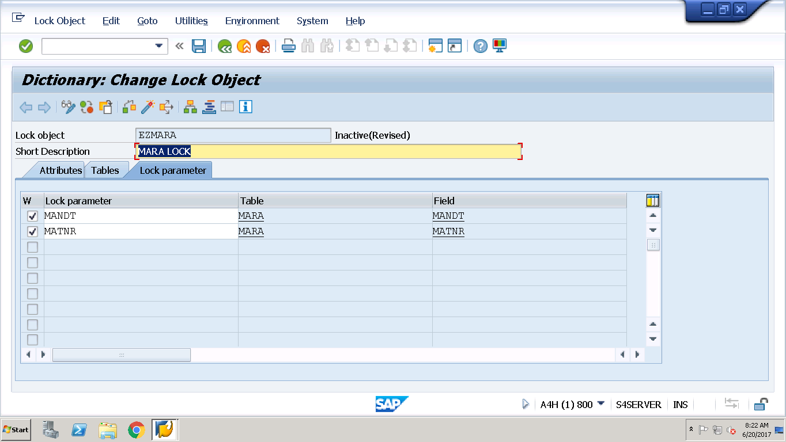

Activate it and it generated TWO Function Modules.

ENQUEUE_<LockObj Name> - > To Lock

Database updation Logic

DEQUEUE_<LockObj Name> -> To Release Lock

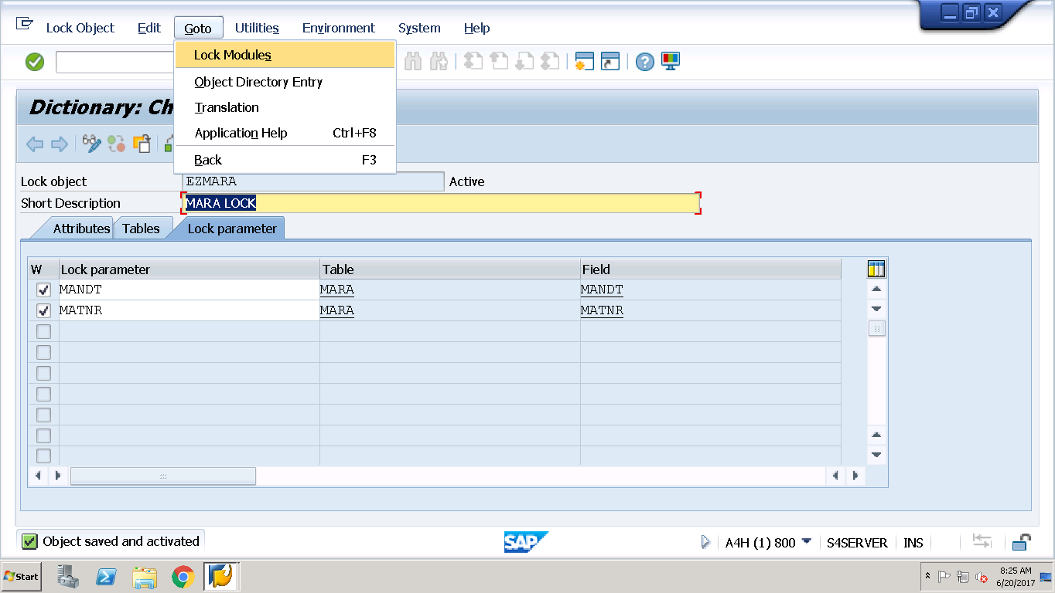

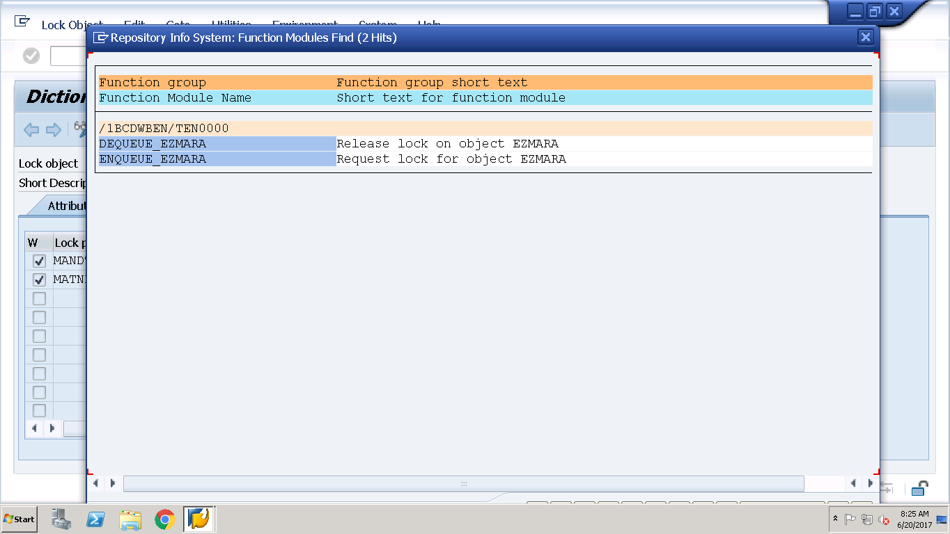

Go To SE37 to see function modules related to lock object created above.

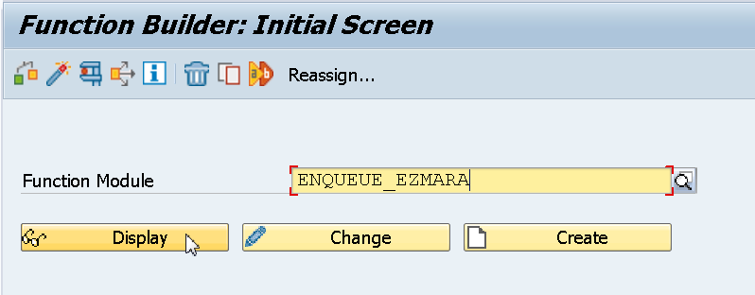

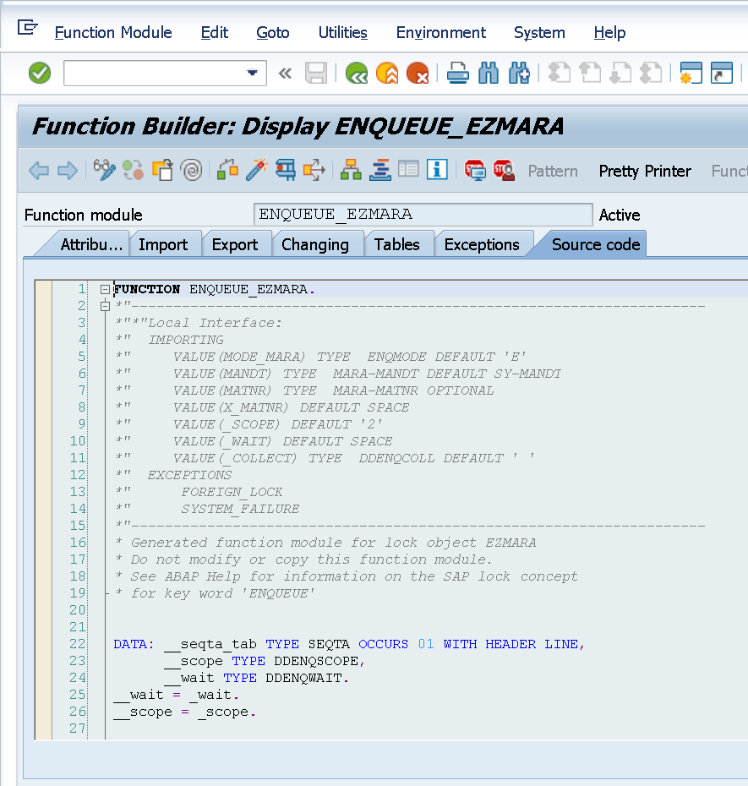

Program to Test the Same.

*\*&---------------------------------------------------------------------\**  
*\*& Report ZAPPLY_LOCK_OBJECTS*  
*\*&---------------------------------------------------------------------\**  
*\*&*  
*\*&---------------------------------------------------------------------\**  
REPORT ZAPPLY_LOCK_OBJECTS.  
PARAMETERS p_matnr type matnr.  
  
CALL FUNCTION 'ENQUEUE_EZMARA'  
 EXPORTING  
*\*   MODE_MARA            = 'E'*  
*\*   MANDT                = SY-MANDT*  
   MATNR                =   p_matnr  
*\*   X_MATNR              = ' '*  
*\*   _SCOPE               = '2'*  
*\*   _WAIT                = ' '*  
*\*   _COLLECT             = ' '*  
*\* EXCEPTIONS*  
*\*   FOREIGN_LOCK         = 1*  
*\*   SYSTEM_FAILURE       = 2*  
*\*   OTHERS               = 3*  
          .  
IF sy-subrc <> 0.  
*\* Implement suitable error handling here*  
ENDIF.  
          .  
IF SY-SUBRC = 0.  
*\* Implement suitable error handling here*  
MESSAGE i001(z104329msgclas) with 'successful'.  
ENDIF.  
  
UPDATE mara set matkl = '0001' where matnr = p_matnr.  
  
BREAK-POINT.  
  
  
CALL FUNCTION 'DEQUEUE_EZMARA'  
*\* EXPORTING*  
*\*   MODE_MARA       = 'E'*  
*\*   MANDT           = SY-MANDT*  
*\*   MATNR           =*  
*\*   X_MATNR         = ' '*  
*\*   _SCOPE          = '3'*  
*\*   _SYNCHRON       = ' '*  
*\*   _COLLECT        = ' '*  
          .

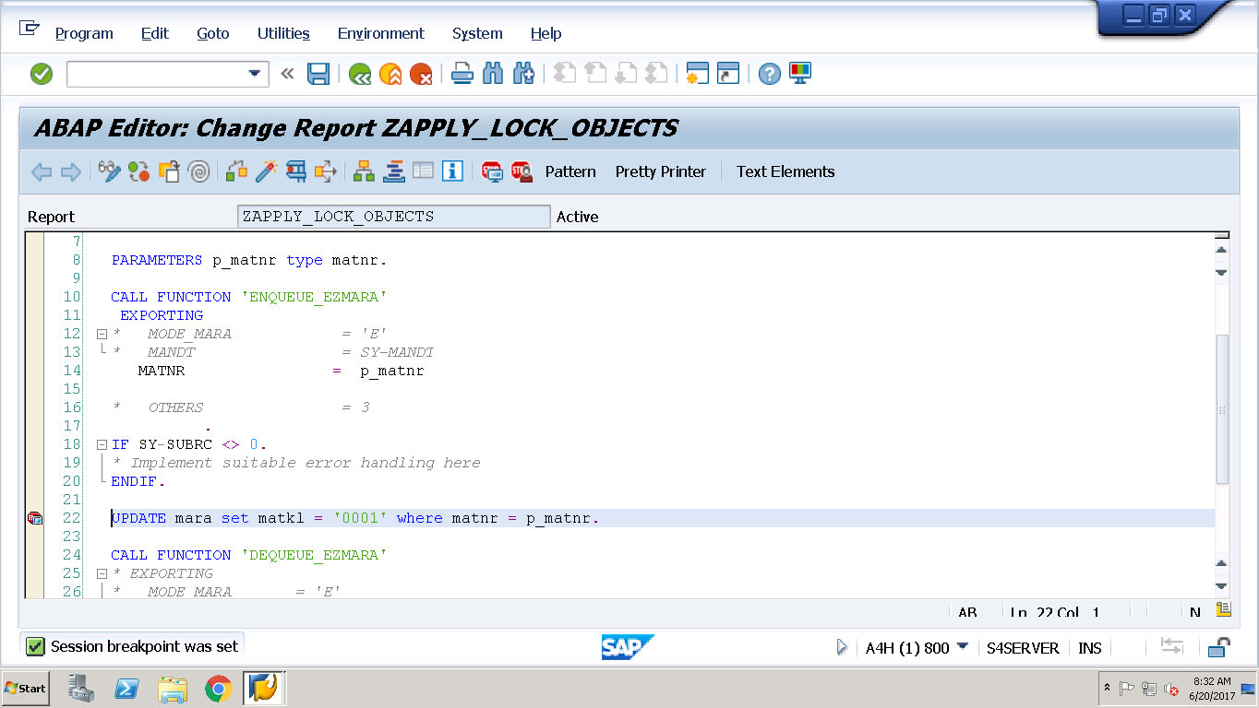

Execute the above using f8. Select Mat number and press enter. Notice the Break point is after Locking but before releasing the lock and meanwhile if the same material is tried to be changed by any, we should get the message.

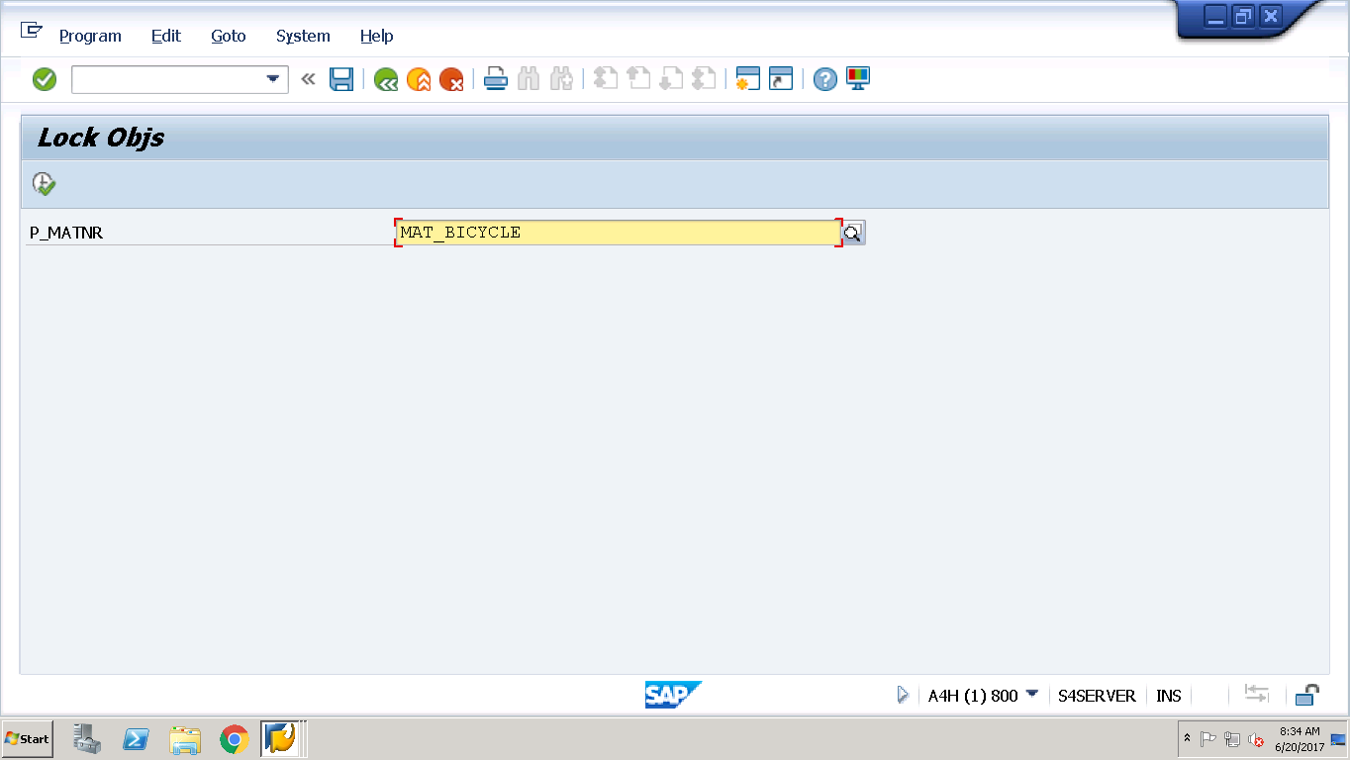

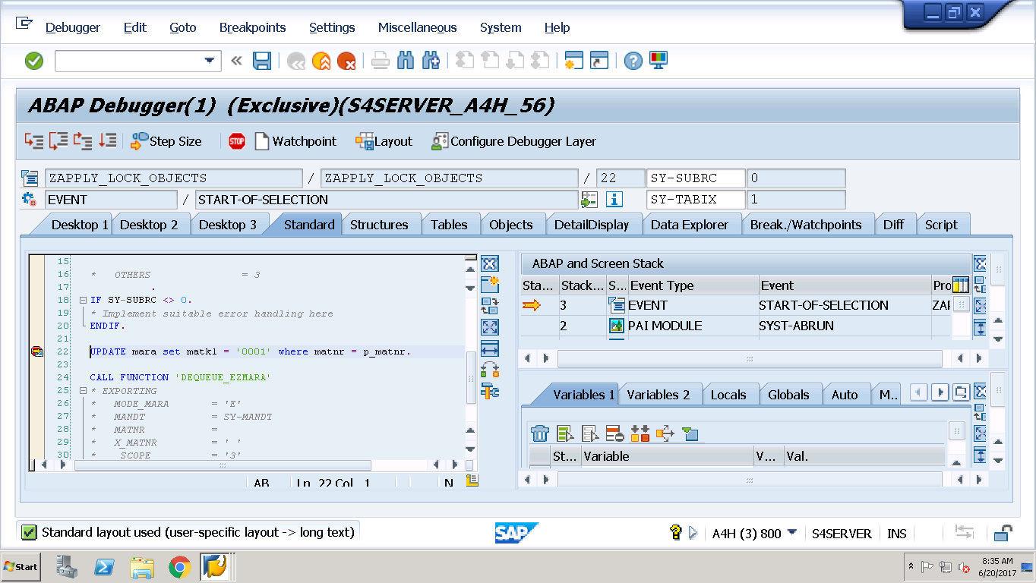

Then open another /omm02 and select the same material.

Try to change the material via MM02

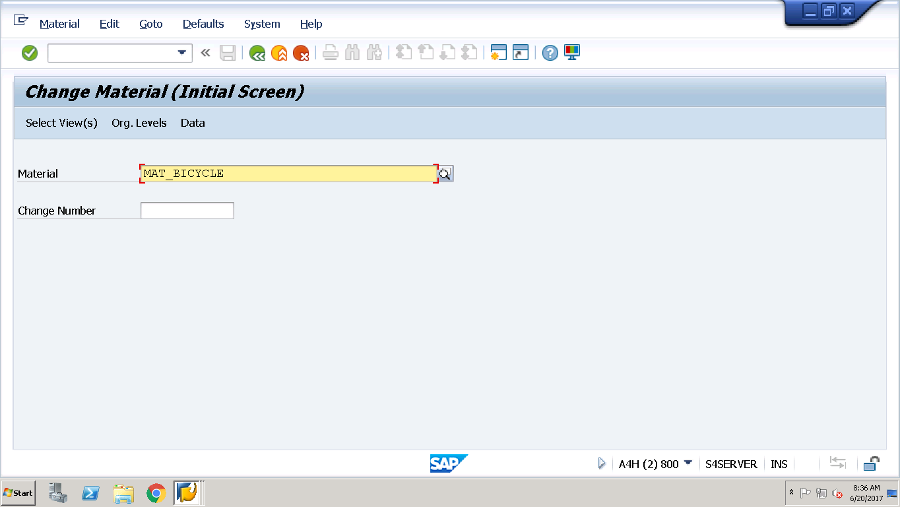

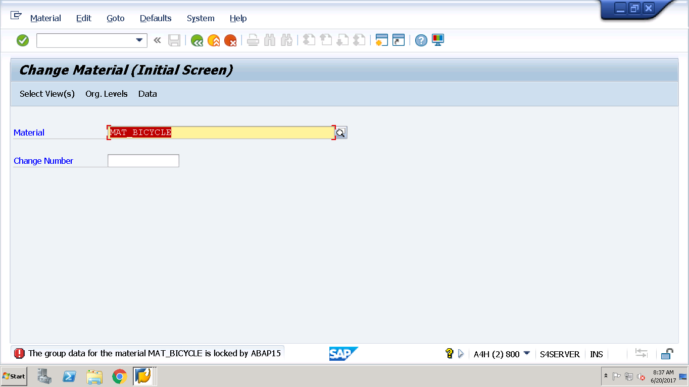

See the Message.